**CENWP-ODJ12/10/2024**

**MEMORANDUM FOR THE RECORD**

**SUBJECT: *24JDA23 Sturgeon Mortality During NFL Dewatering***

On 2 December 2024, a 65” sturgeon died while dewatering the upper section of the JDA north fish ladder (NFL).

At JDA fish ladder salvages are performed by laying on a skateboard and gliding through each overflow weir orifice to quickly respond to stranded fish, bag them, and get them released back into the river as quickly as possible. For safety purposes someone must walk the outside of the ladder and keep visual contact on the personnel going through the ladder.

At JDA both fish ladders are missing extensive sections of guardrail around the perimeter (they were never installed). Therefore, the person monitoring the skateboard personnel must wear a harness and utilize a double tie-in lanyard to walk these areas. In the case of the NFL this area starts just downstream of the count station and continues to the upper-180 (see figure 1). In order to keep this person safe, traffic around this area is reserved for the safety monitor, meaning they also have to pull fish-filled bags out of the ladder and walk them to either the count station or to the upper-180. These bags are packed as light as possible for safety purposes.

During the dewatering there was a 48” sturgeon in the upper portion of the NFL (see figure 1). Due to the weight and size, it was infeasible to bag the fish and pull it out of the ladder at this location. Therefore, the fish salvage crew had to guide the sturgeon, through numerous overflow weir orifices, down to the upper-180 where another crew was able to retrieve and release the fish in good condition.

Unfortunately, while the crews were saving the 48” sturgeon, another 65” sturgeon was stranded at the lower-180 (see figure 1). Crews were unaware the sturgeon was there. When the salvage crew finally made it to the sturgeon, it was still alive. They had to guide the fish through numerous overflow weirs orifices, and into the tailwater (see figure 1). The sturgeon was deemed to heavy to safely pull out of the ladder and getting it into the tailwater was thought to be the safest option for all parties involved.

When the sturgeon made it to the tailwater, it seemed fine. However, the next day JDA personnel noticed the fish was in the same location (see figure 2). When it was clear the sturgeon hadn’t moved, a rope with a weight was gently lowered down to the fish, and it was clearly unresponsive. Retrieval and verification weren’t possible until the tailwater was dewatered on 9 December 2024 (hence the late reporting).

It’s very rare to have sturgeon in the JDA fish ladders. Typically, there are only a few salmonids, and the bulkhead leakage is sufficient to keep them alive until crews can salvage them. This incident caught JDA by surprise and JDA Fisheries is currently (at the time this memo is being submitted) modifying the standard operating procedures to help ensure this never happens again.

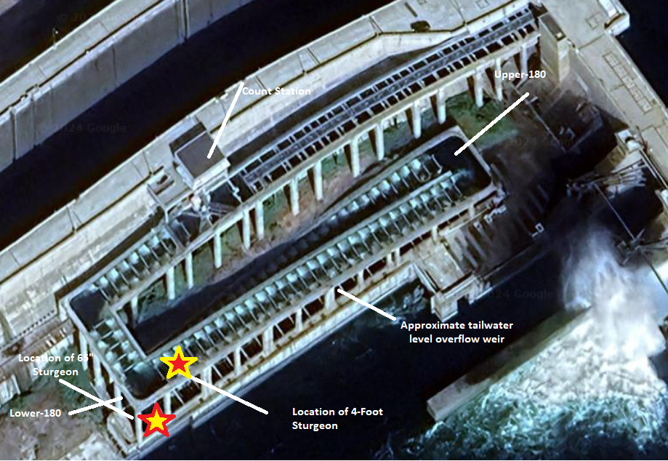

Figure 1: Map of the NFL. The yellow star with the red fill is the location of the 48” sturgeon that was released in good condition. The red star with the yellow fill is the loaction of the 65” sturgeon when rescue operations began. The “approximate tailwater level overflow weir” is how far the sturgeon had to be guided to get it back into the water.

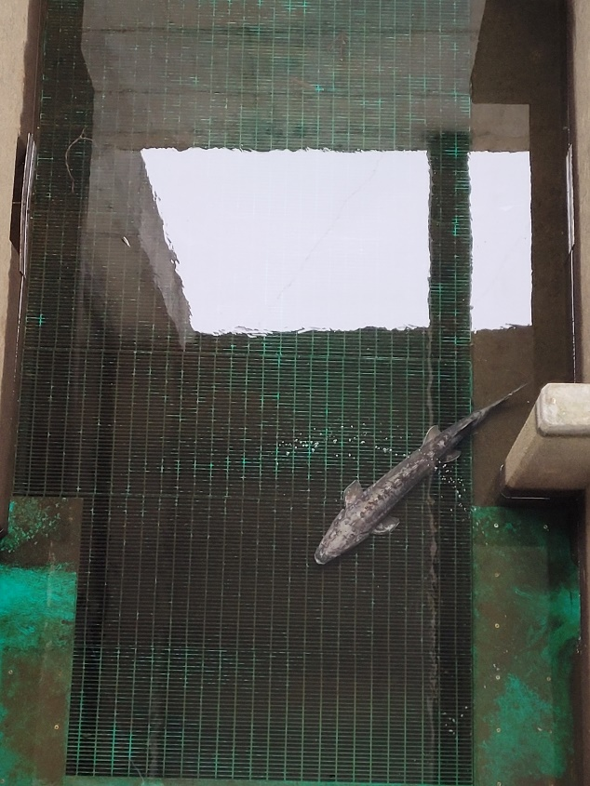

Figure 2: The 65” sturgeon mortality in the NFL tailwater before the entrance was dewatered, and before personnel could officially verify it was dead.

1. Origin – Unknown
2. Length – ~65” fork length
3. Marks and tags – No visible marks/tags. It was scanned for PIT tags, and none were found.
4. Marks and Injuries found on carcass – A few minor scratches, but nothing serious.
5. Cause and Time of Death – 2 December 2024 sometime after 1530.
6. Future and Preventative Measures- This incident has shown a glaring deficiency in the JDA fish ladder dewatering standard operating procedures (SOP). The SOP is under revision at the time this memo is submitted. One of the main emphases is to have someone walk the entire perimeter of the ladder (that isn’t missing guardrail) ASAP and ensure there are no stranded fish. If fish are found, a second crew will be available to enter the ladder at either the upper or lower 180 and retrieve the fish as quickly as possible.

Sincerely,

Project Fisheries